1. Table_create:

Syntax:

Create table table_name (“column_name1”(data_type),”column_name2”(data_type),”column_name3”(data_type)

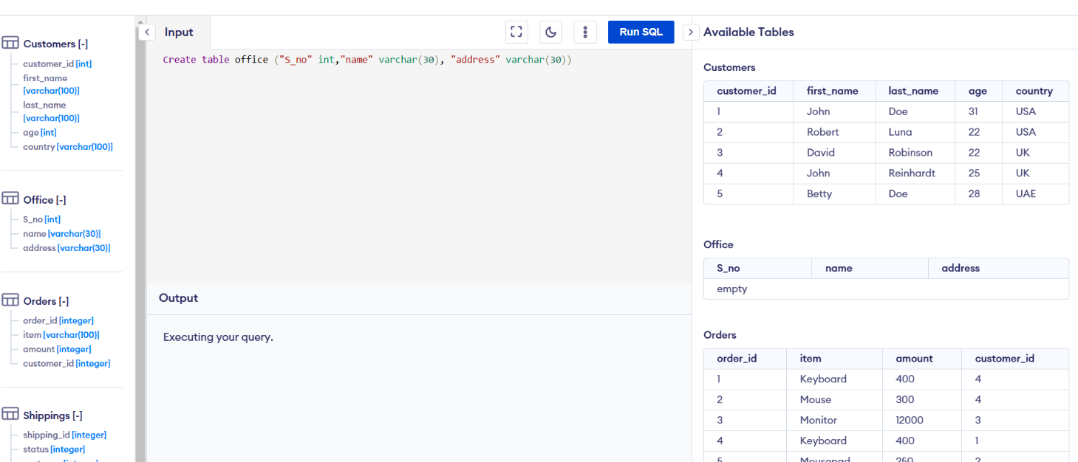

1. Insert values:

Syntax:

Insert into table_name

Values(val1,val2,val3),(val1,val2,val3)

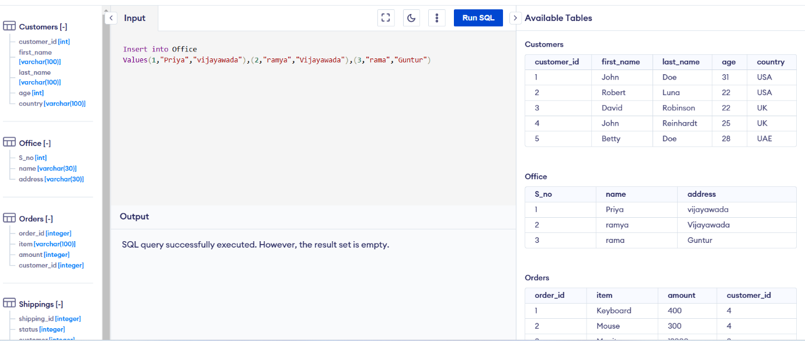

1. Data retrieve (all values)

Syntax:

Select *

From table_name

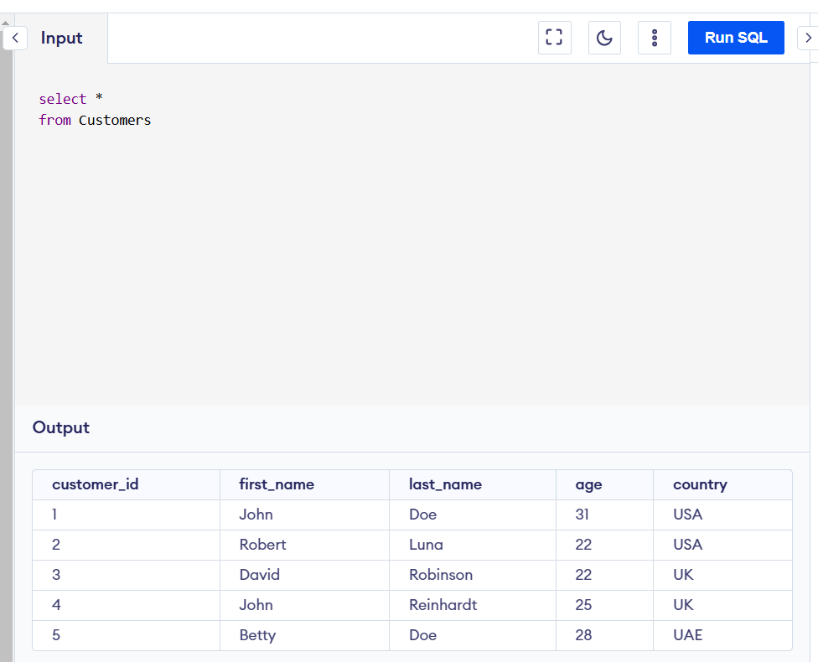

1. Filter (single_value)

Synatax:

Select *

From table_name

Where column_name=”value”

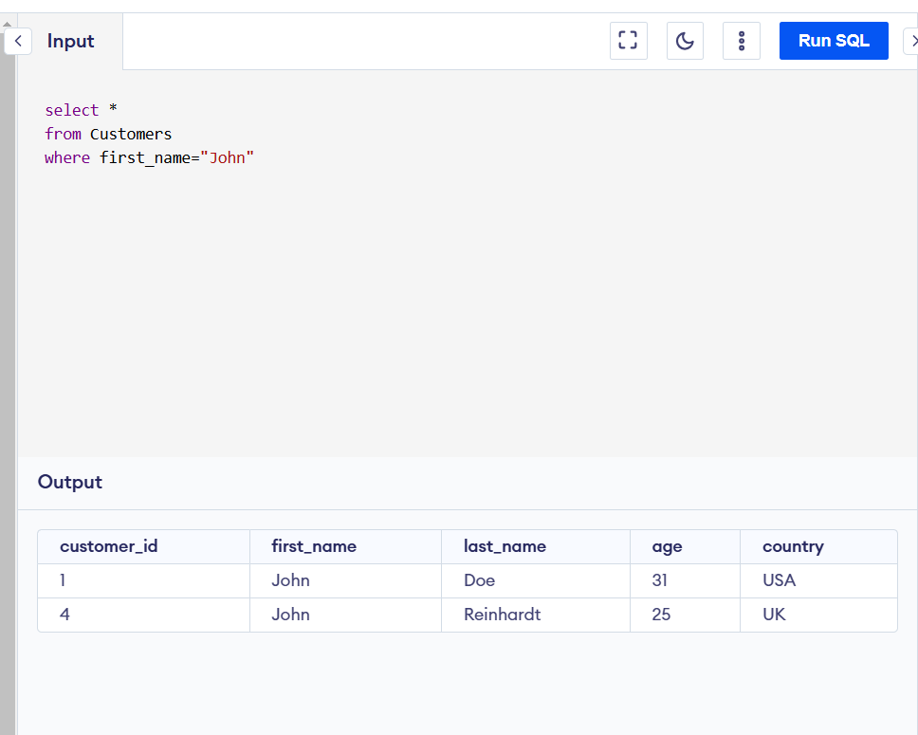

1. Conditions (and & or):

Syntax:

Select *

From table_name

Where column_name1=”value” and column_name2=”value”

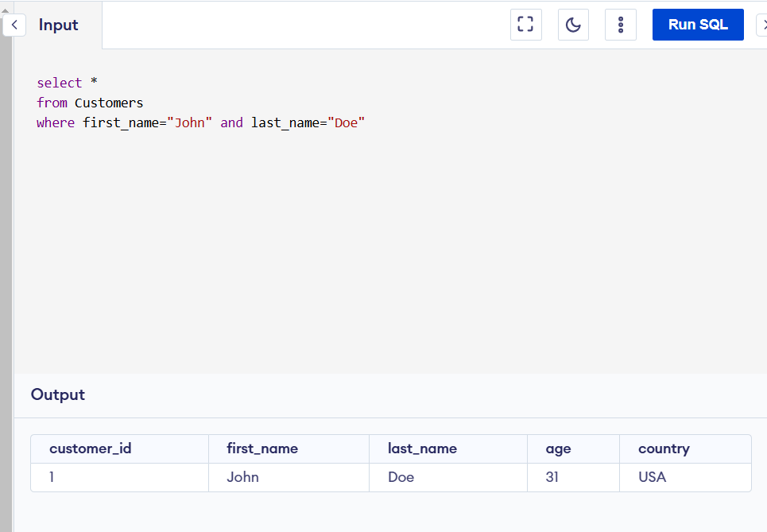

Syntax:

Select *

From table_name

Where column_name1=”value” or column_name2=”value”

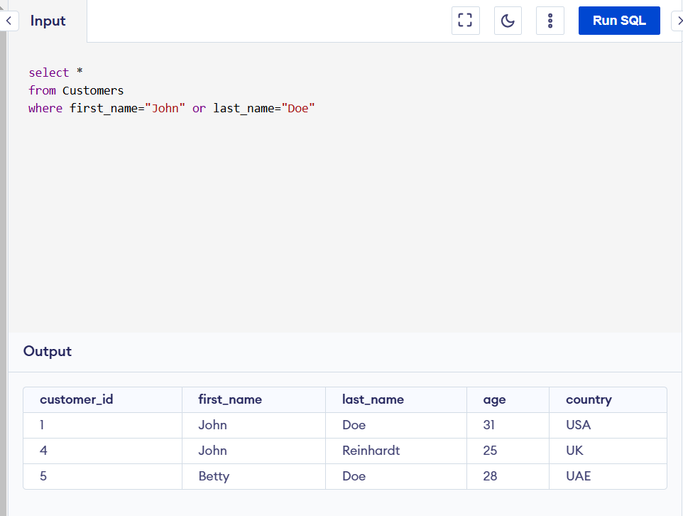

1. Multiple conditions:

Select *

From table_name

Where (column_name1=”value” and column_name2=”value”) or column_name3=”value”

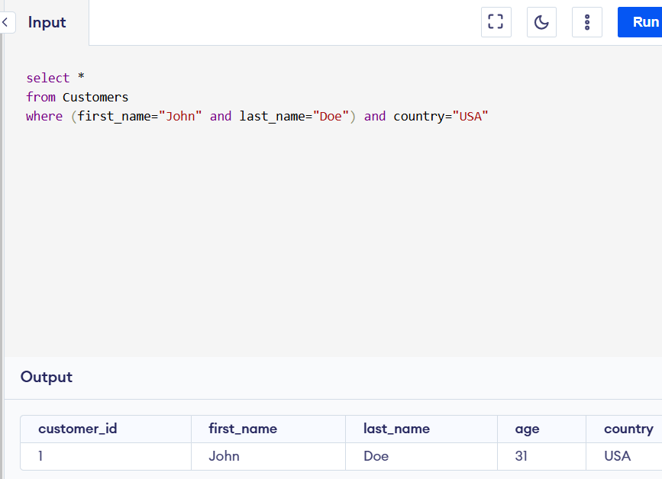

1. Update table(values):

Syntax:

Update table_name

Set column_value=”value”

Where column_name=”value”

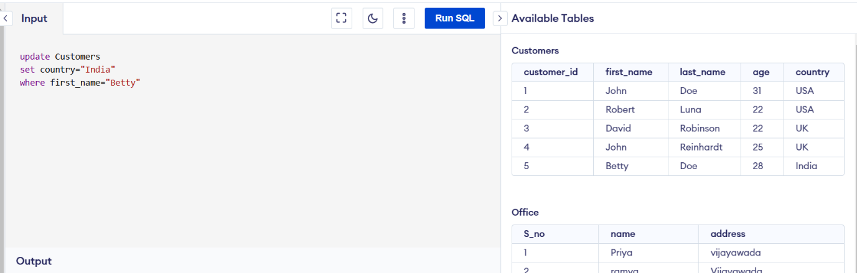

1. Add column in table:

Syntax:

Alter table table_name

Add column column_name

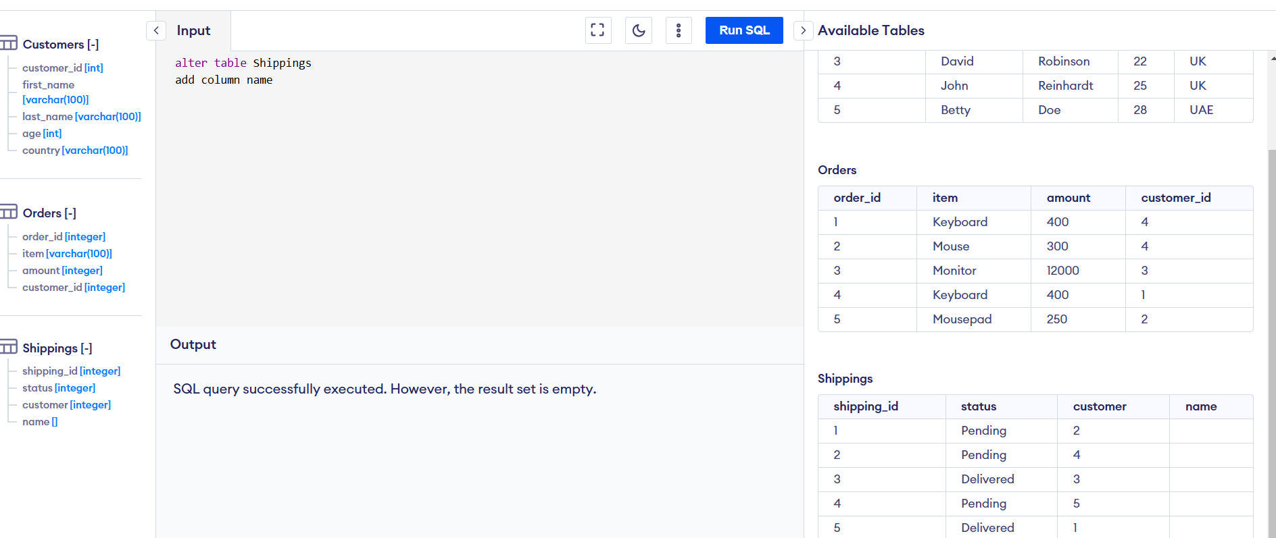

1. Add column (data_type) in table:

Syntax:

Alter table table_name

Add column column_name (data_type)

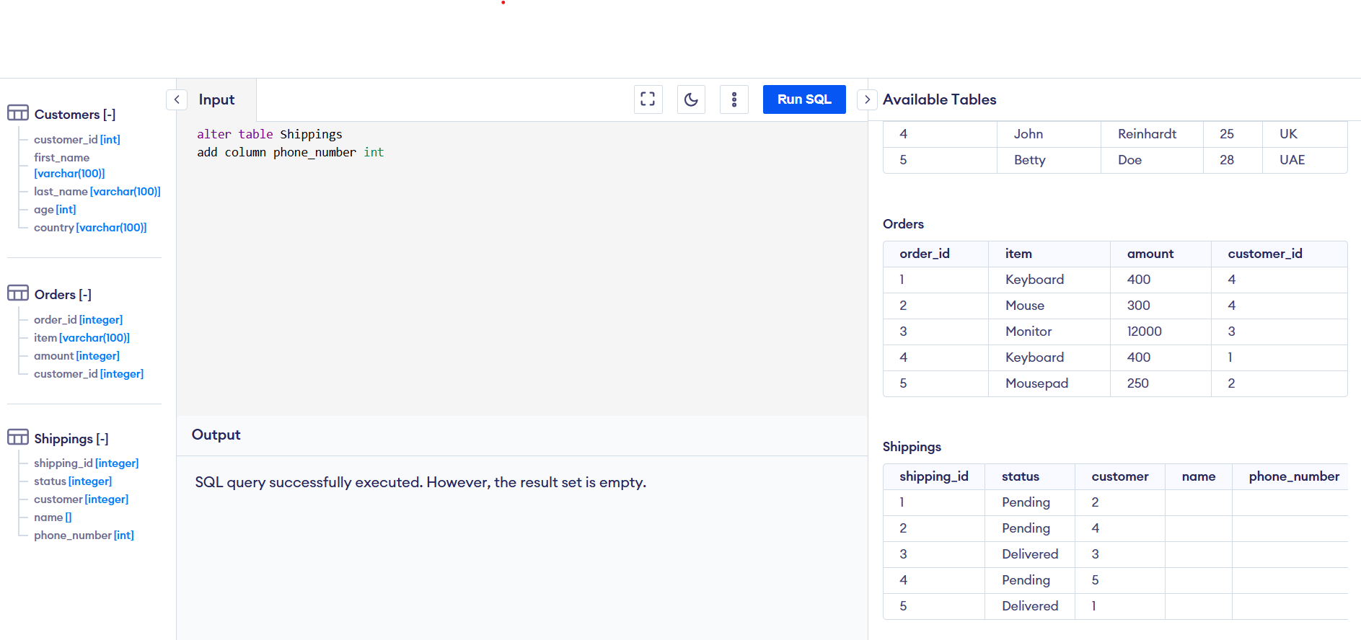

1. Rename column_name:

Syntax:

Alter table table_name

Rename column_name to new_column_name

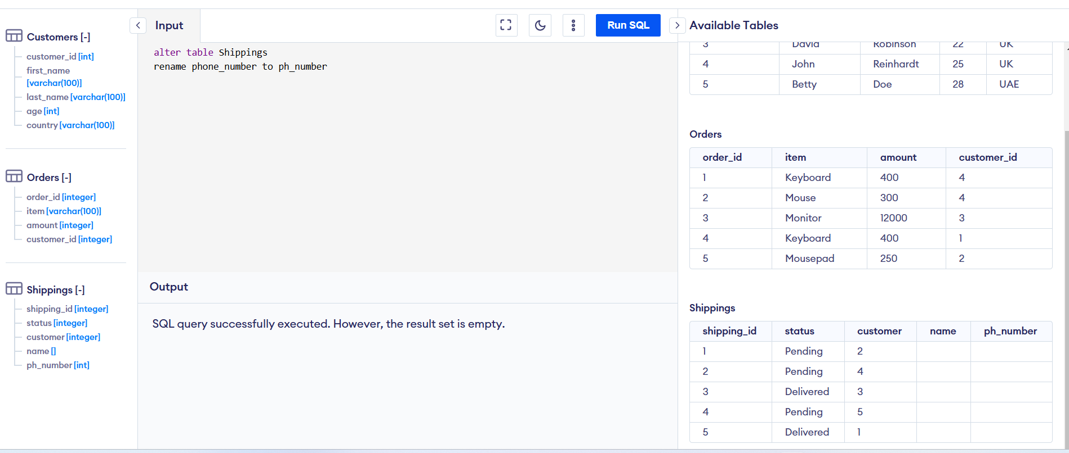

1. Add values in column:

Syntax:

Update table

Set column_name=”value”

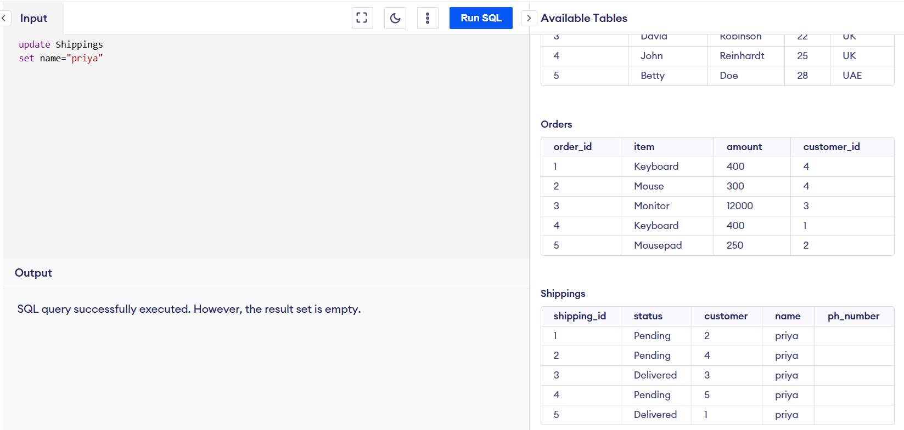

1. Delete value in column:

Syntax:

Delete from table_name

Where column_name = “value”

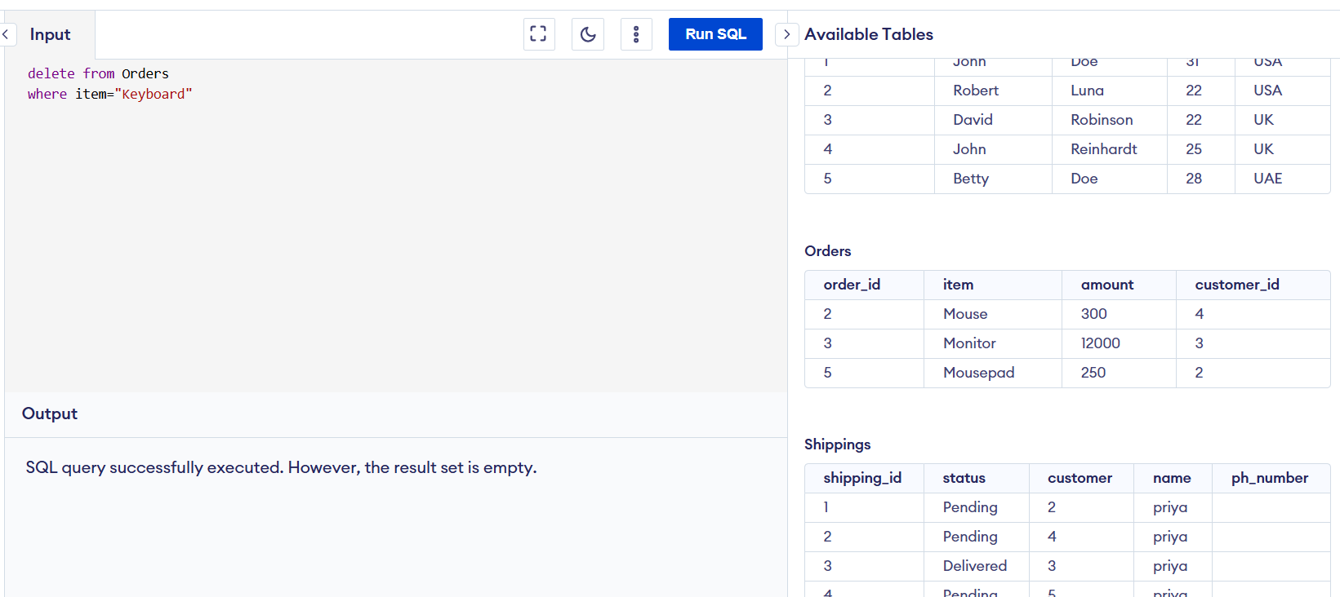

1. Delete all data in table (table is empty)

Syntax:

Delete from table_name

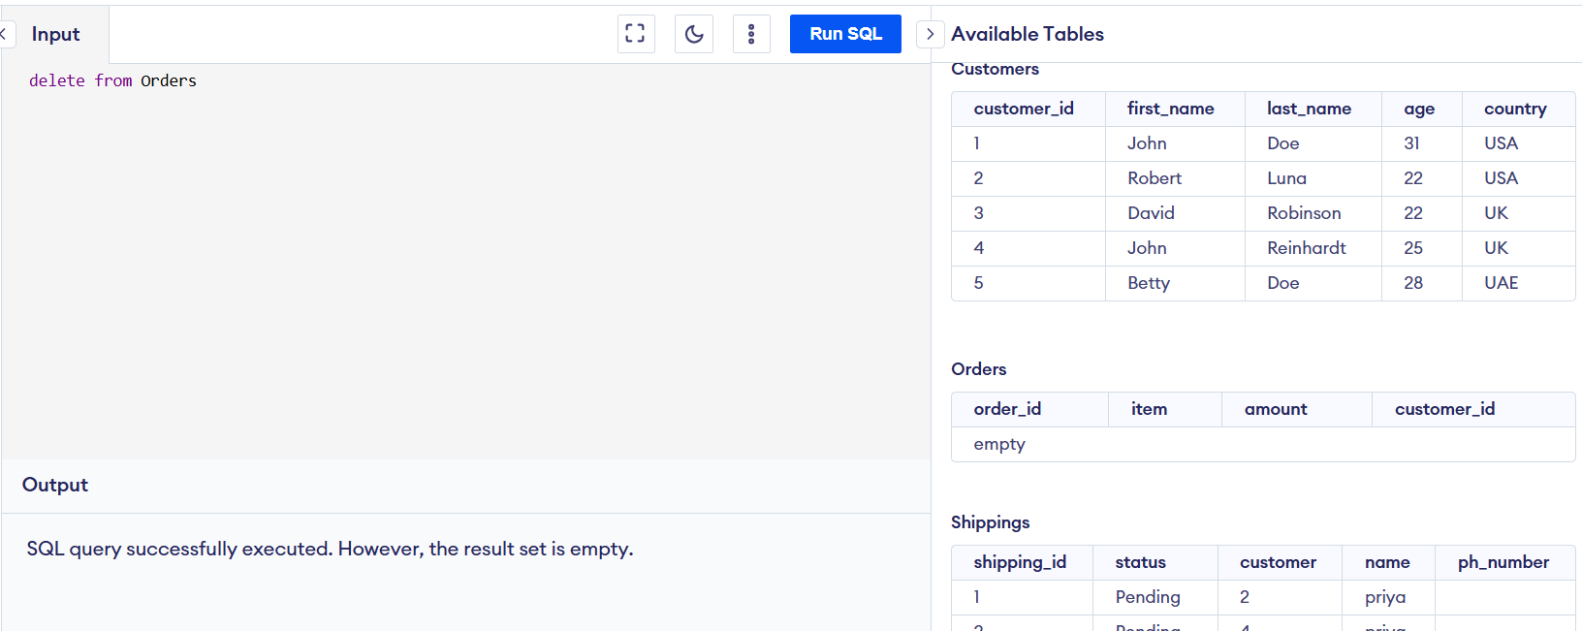

1. Total _table delete

Syntax:

Drop table table_name

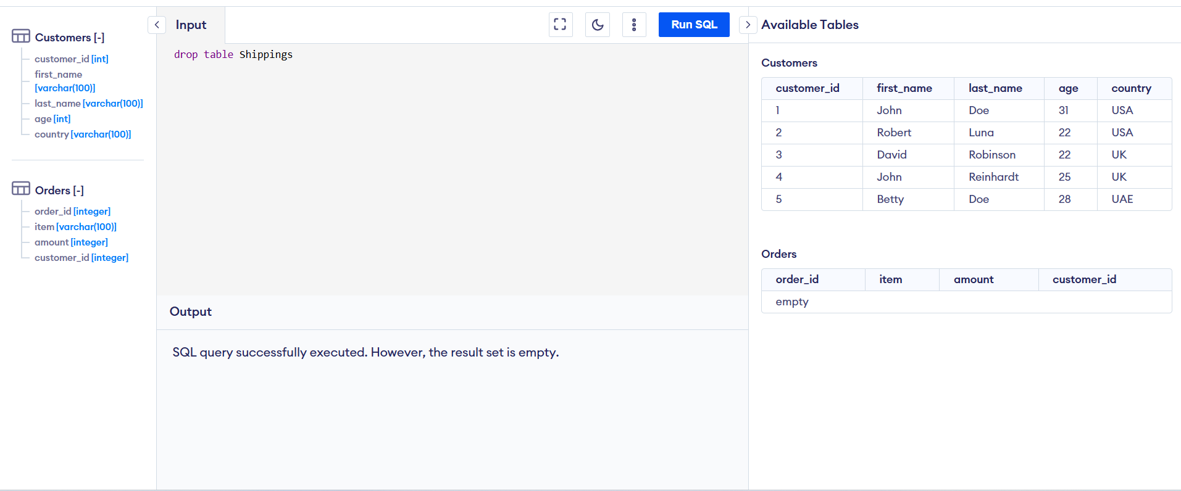

1. Table_rename

Syntax:

Alter table table_name

Rename to new_table_name

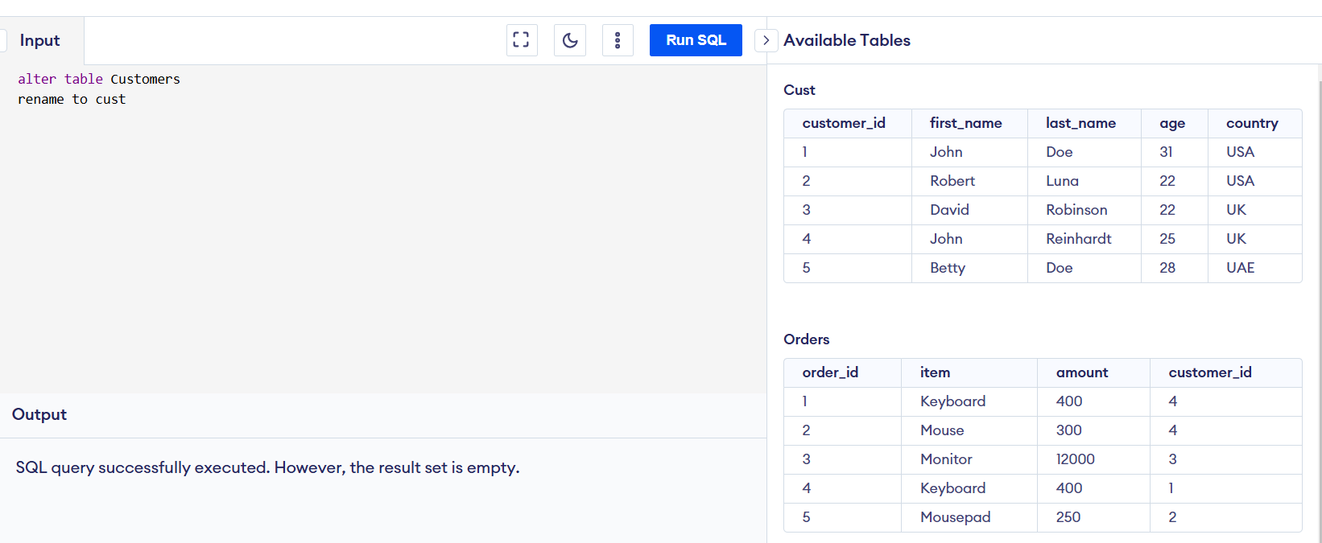

1. Not equal to condition

Syntax:

Select *

From table_name

Where not column_name =”value”

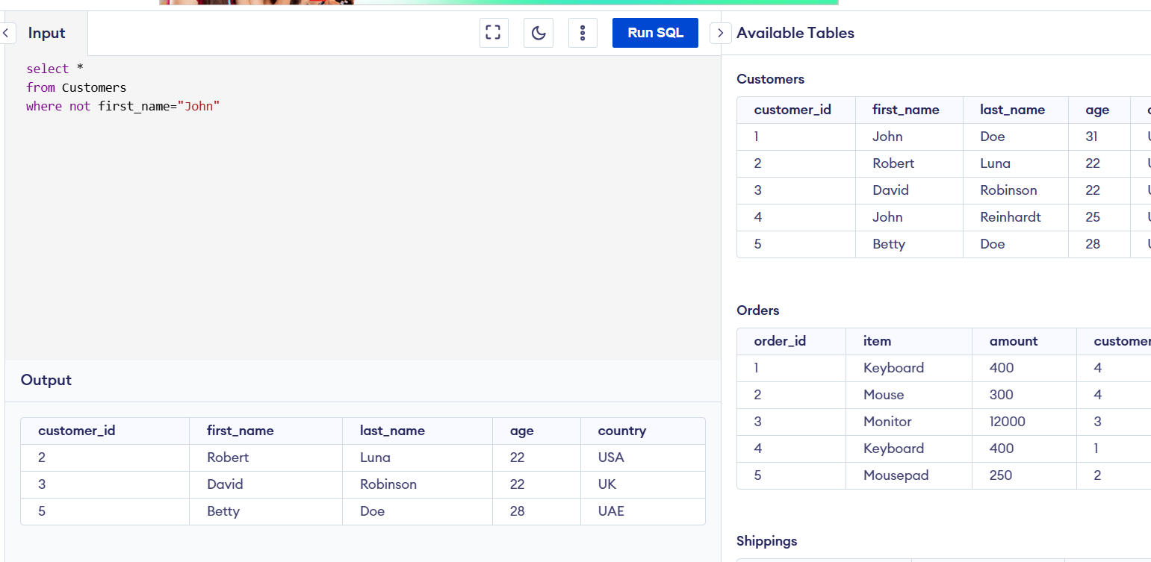

1. Joins(left,right,inner,outer)



Syntax:

Select *

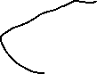

From table1(base table)

Inner join table2(child_table)



On table1.column_name=table2.column_name



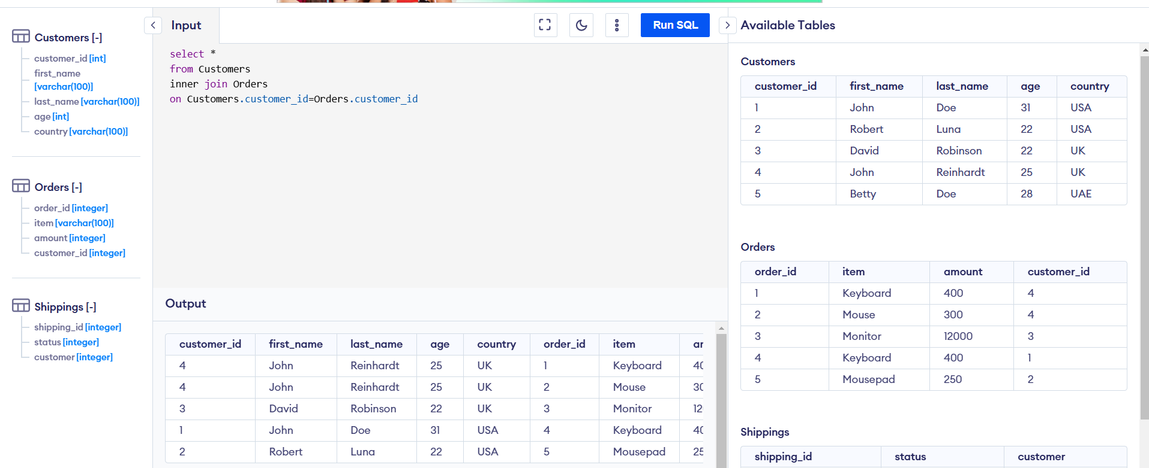

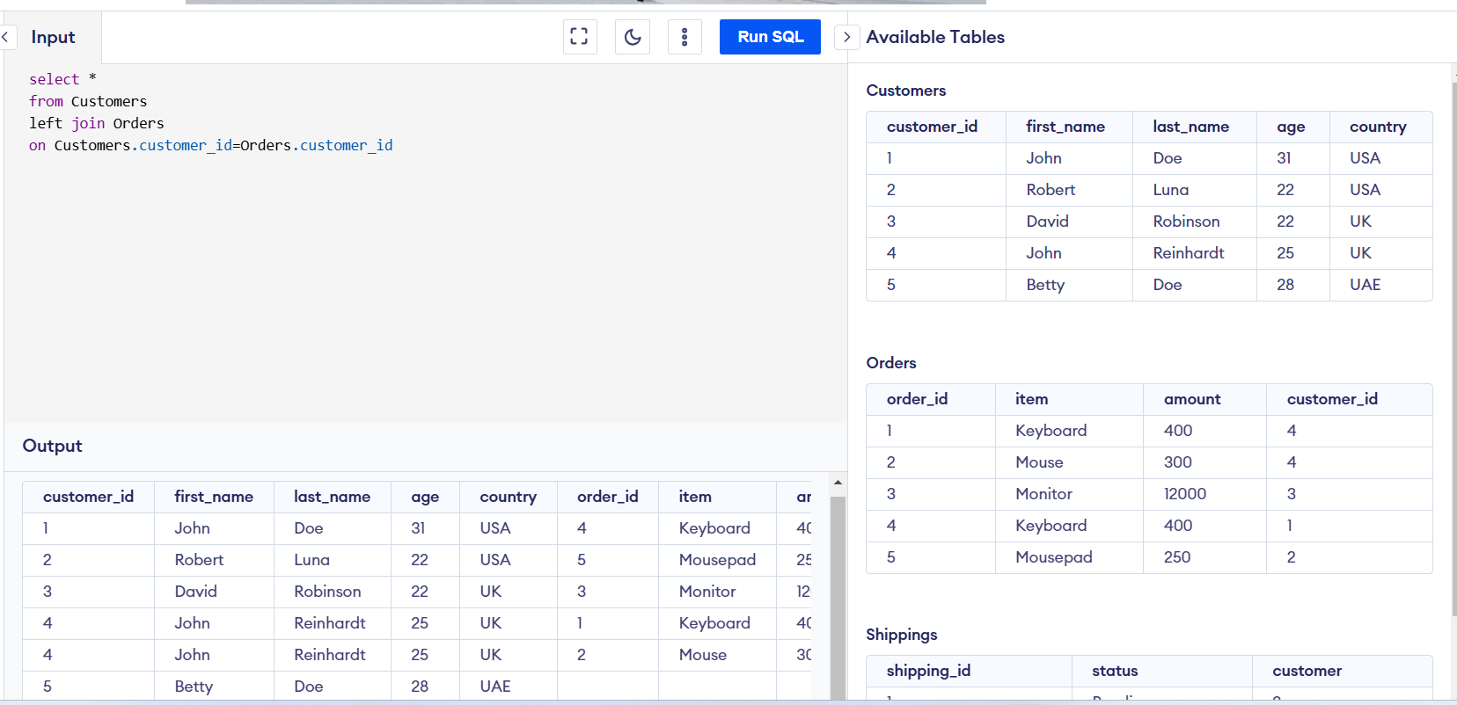

1. In condition

Syntax:

Select *

From table_name

Where column_name in (value1,value2)

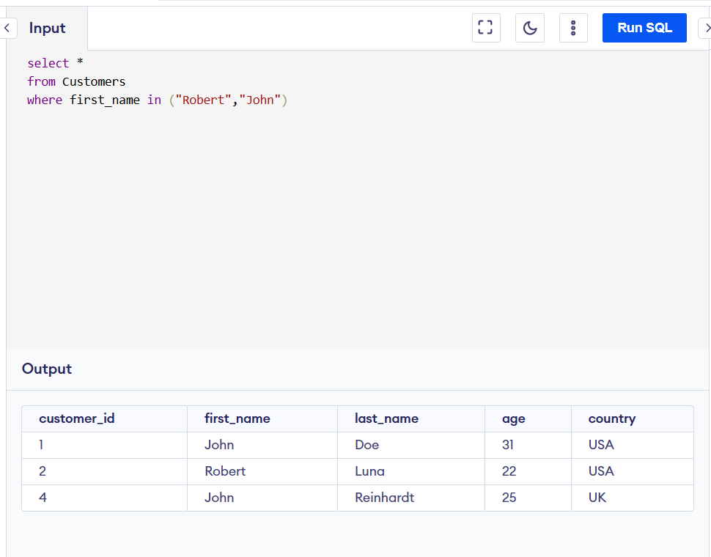

1. Between :

Syntax:

Select *

From table_name

Where column between value1 and value2

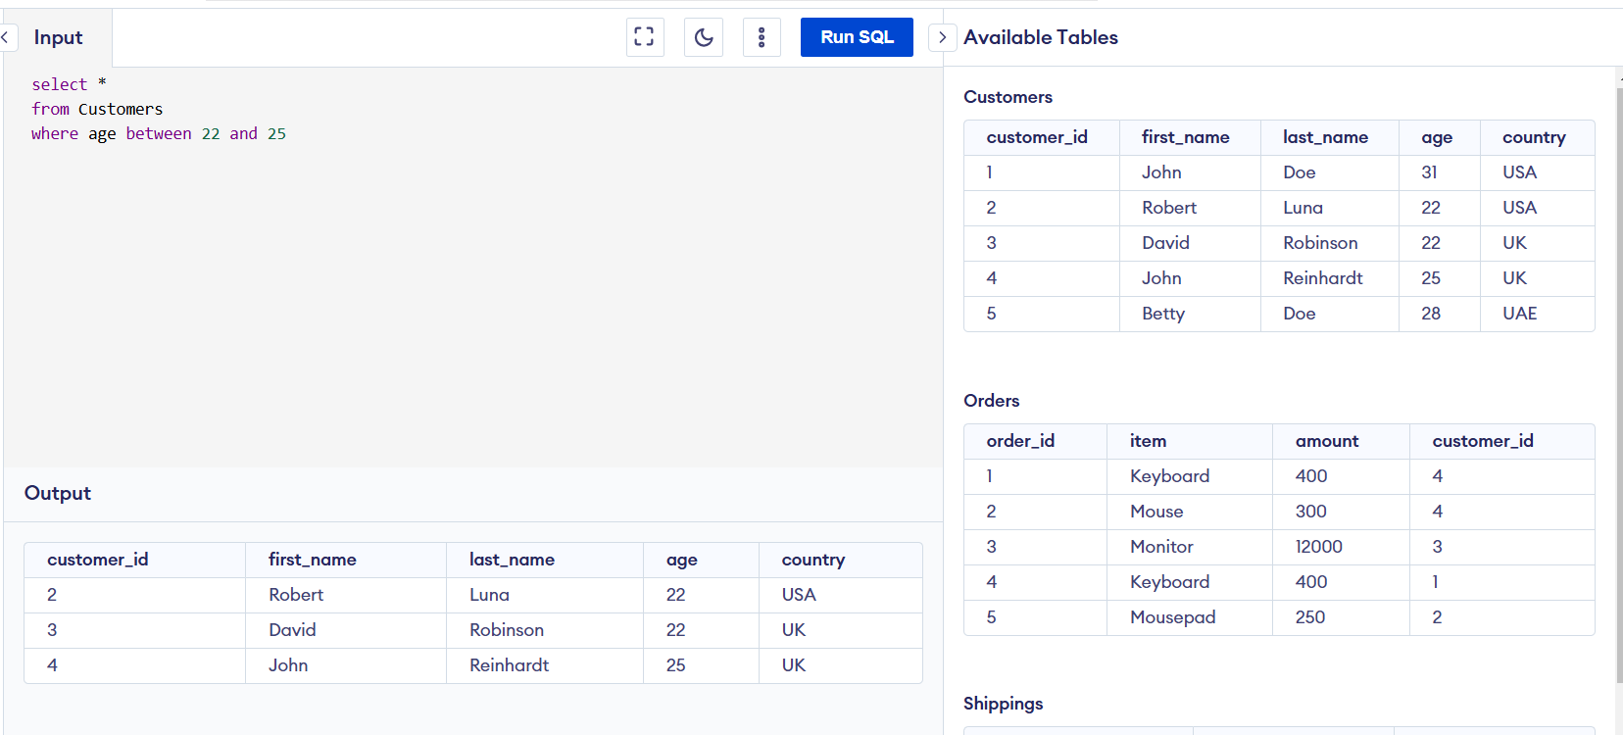

1. Column delete

Syntax:

Alter table table_name

Drop column column_name

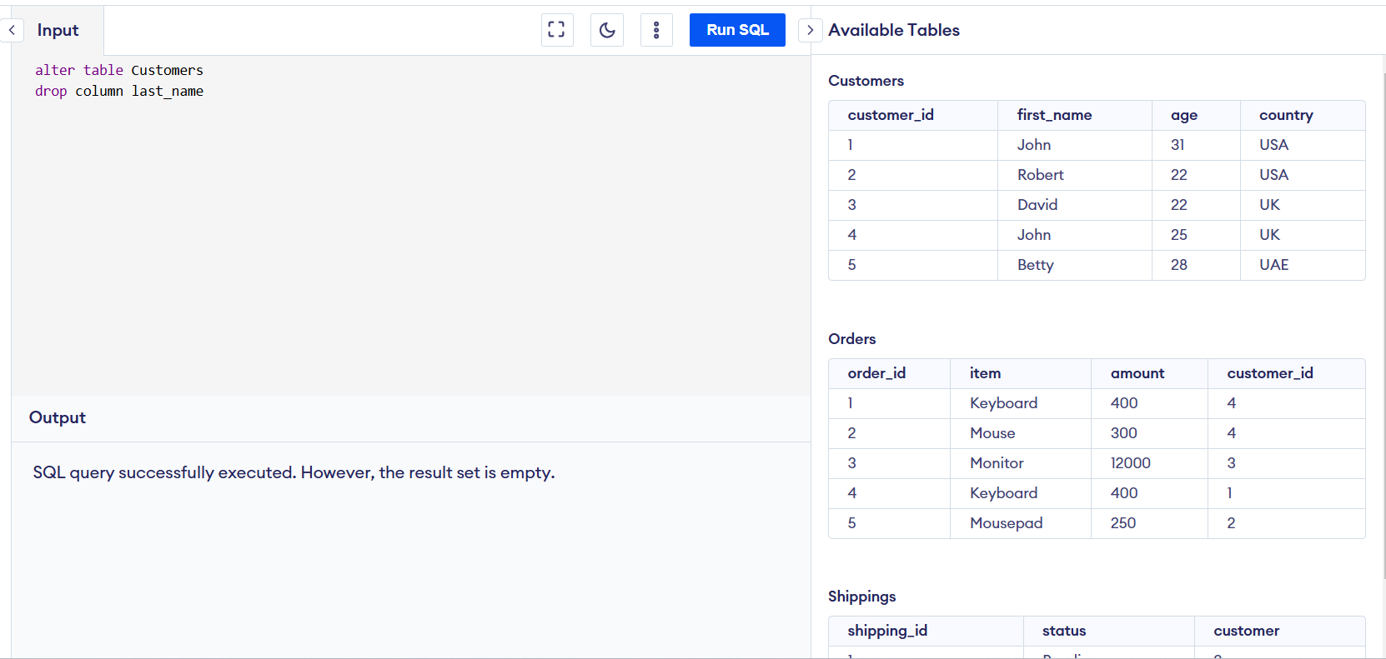

1. Group by :

Syntax:

Select *

From table_name

Group by column_name

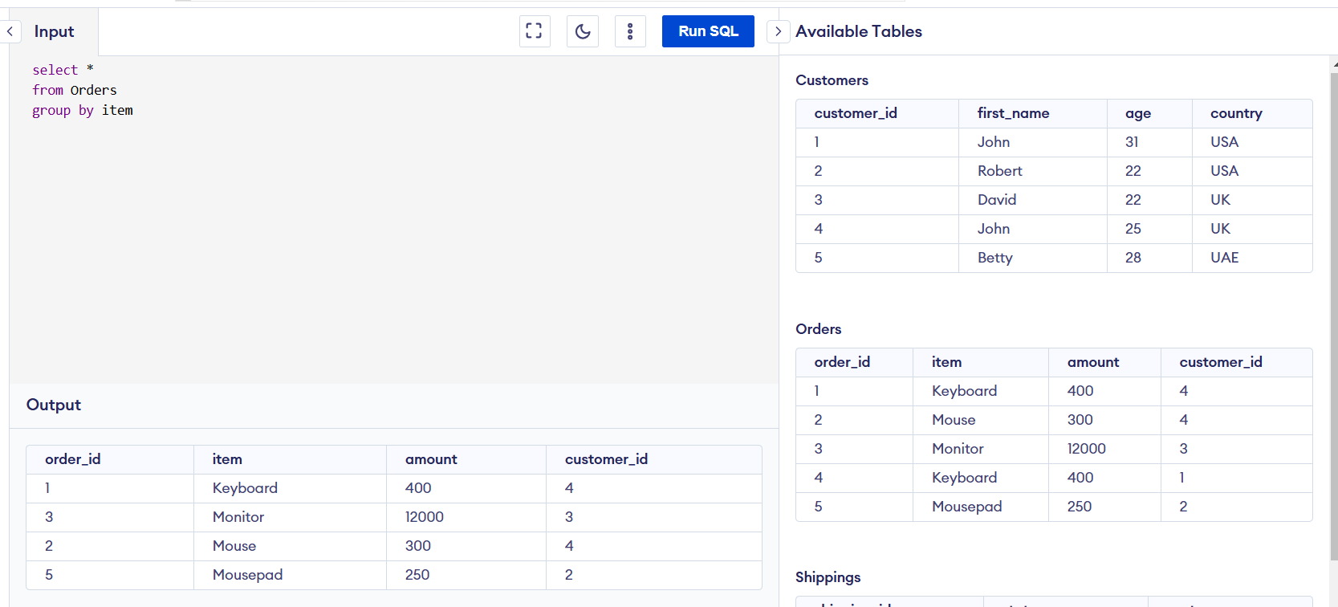

1. Aggregation functions

Syntax :

Select count(column_name)

From table_name

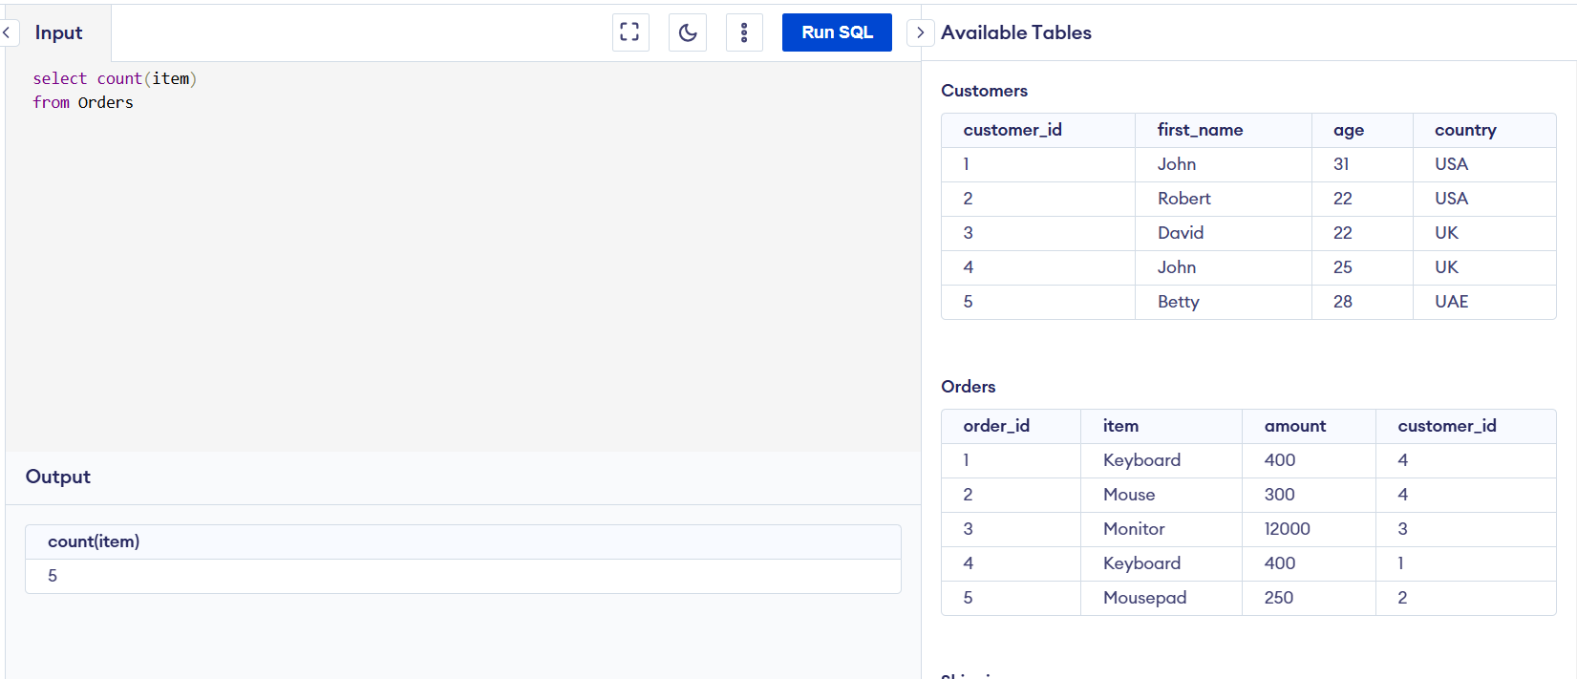

Syntax :

Select distinct(column_name)

From table_name

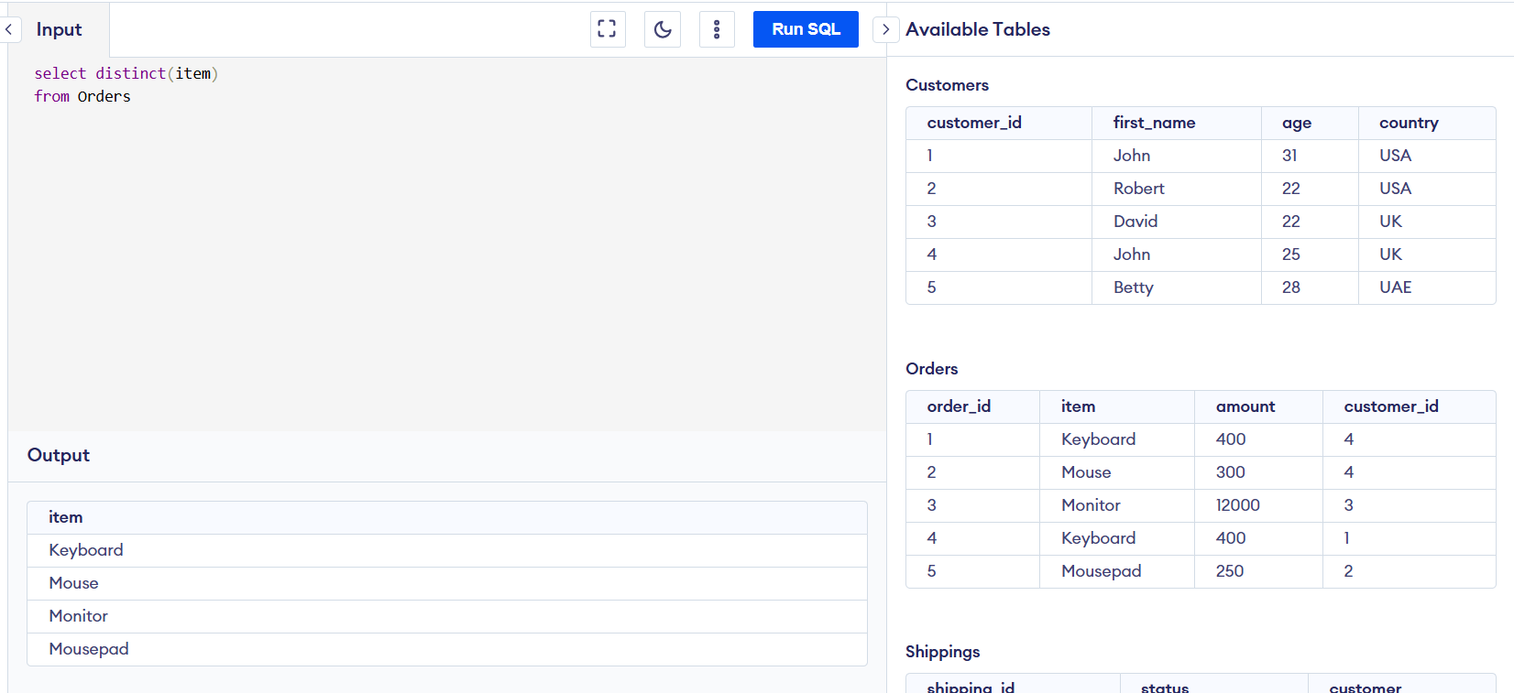

Syntax :

Select max(column_name)

From table_name

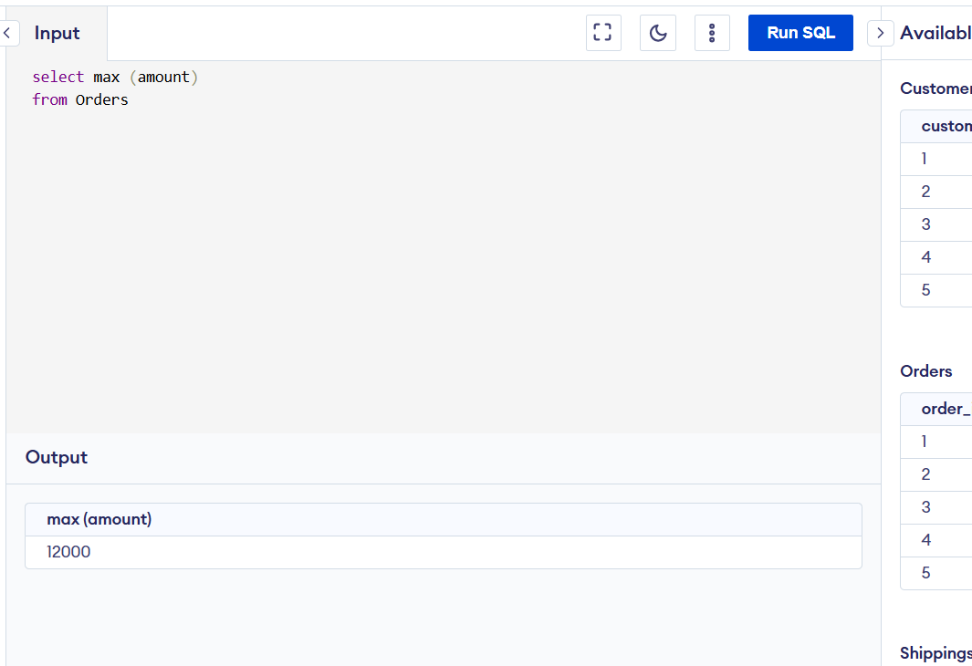

Syntax :

Select min (column_name)

From table_name

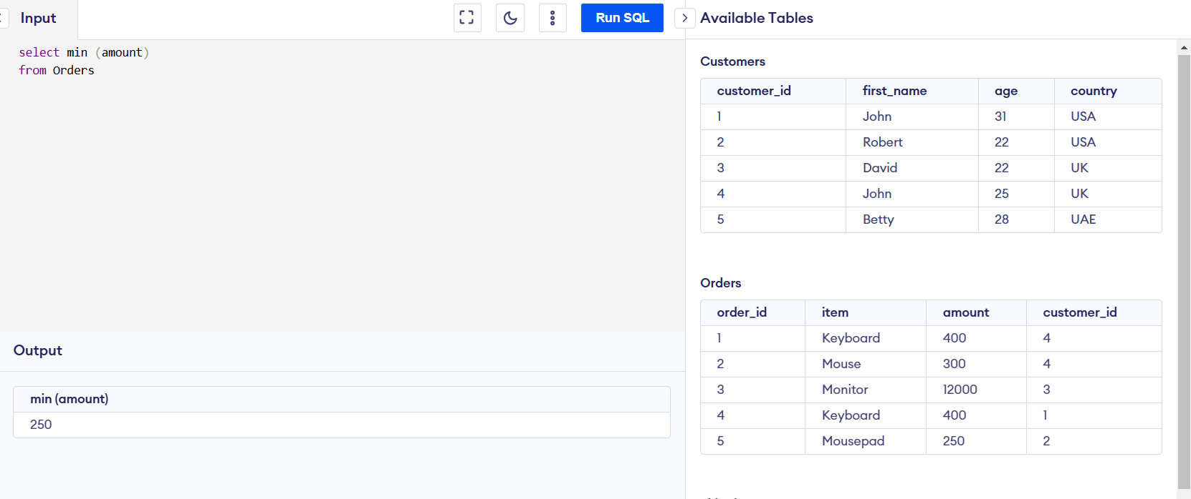

Syntax :

Select sum (column_name)

From table_name

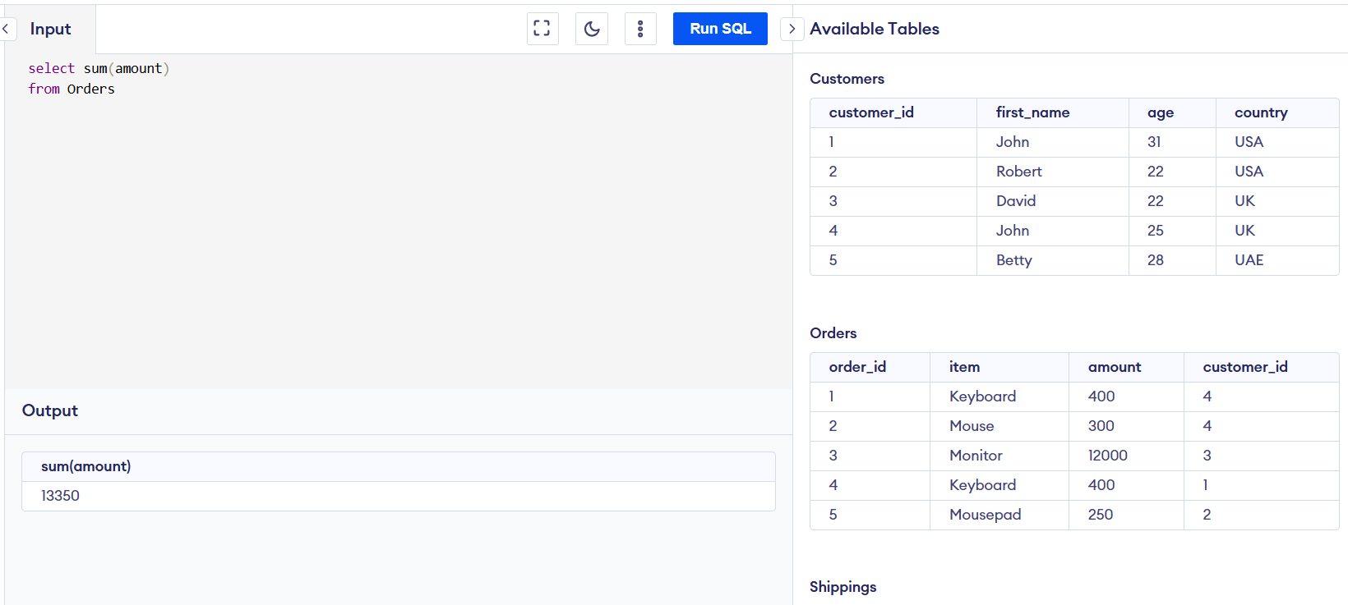

Syntax :

Select avg (column_name)

From table_name

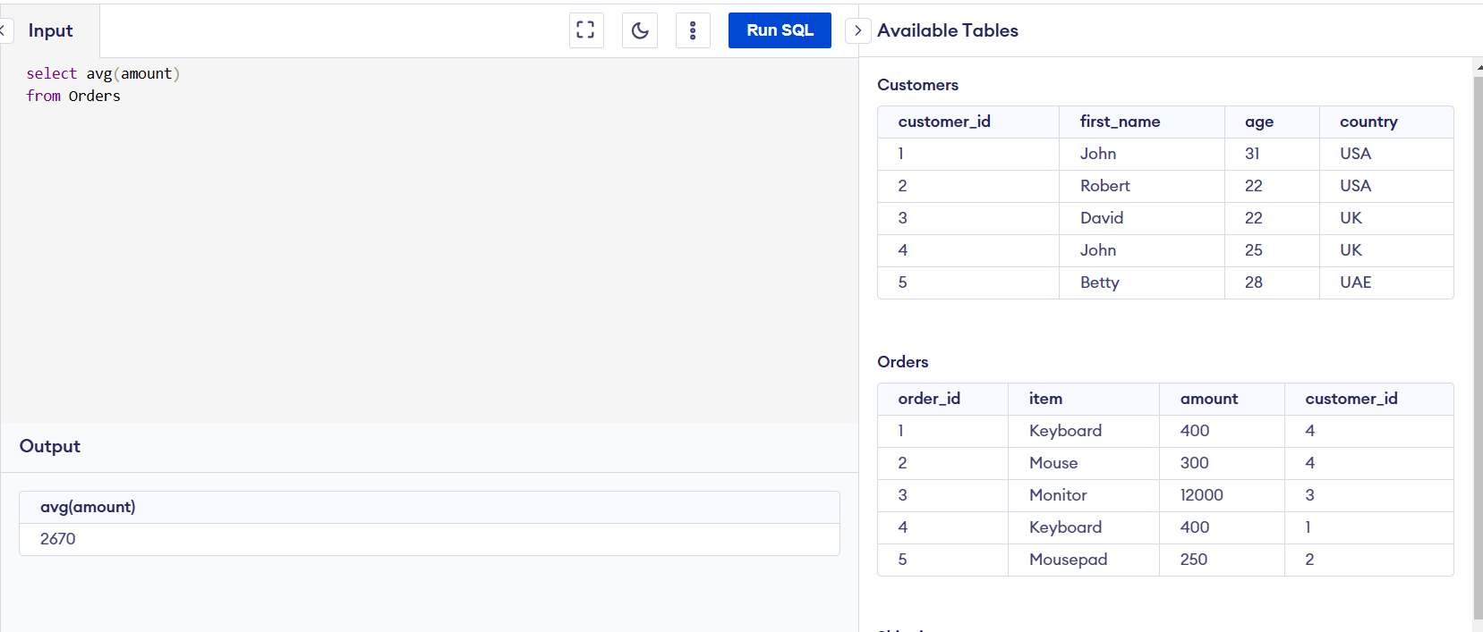

1. Order by

Syntax:

Select *

From table_name

Group by colum_name1

Order by column_name2 asc

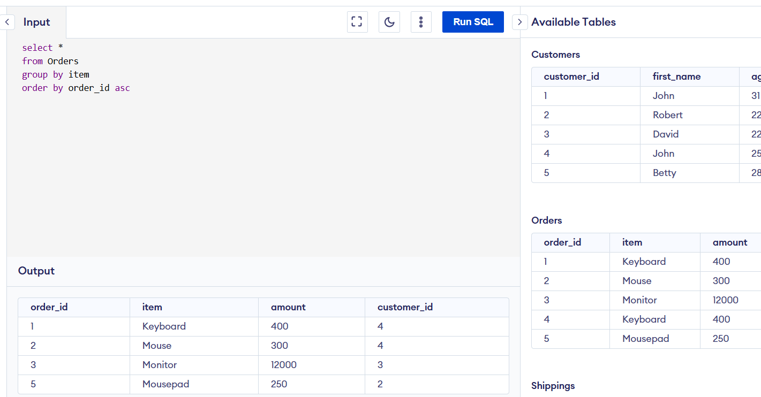

Syntax:

Select *

From table_name

Group by colum_name1

Order by column_name2 desc

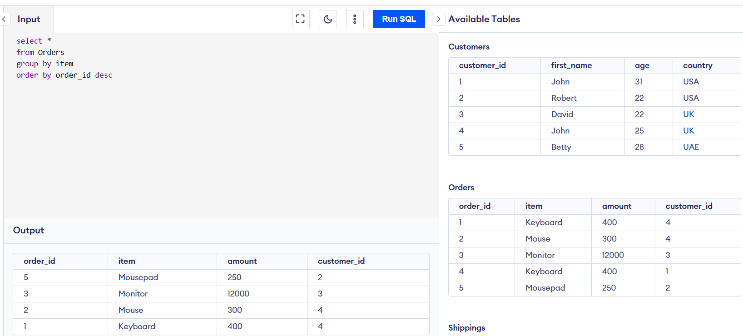

1. Having condition:

Syntax:

Select *

From table_name

Where column_name=”value”

Group by column_name1

Having column_name> value

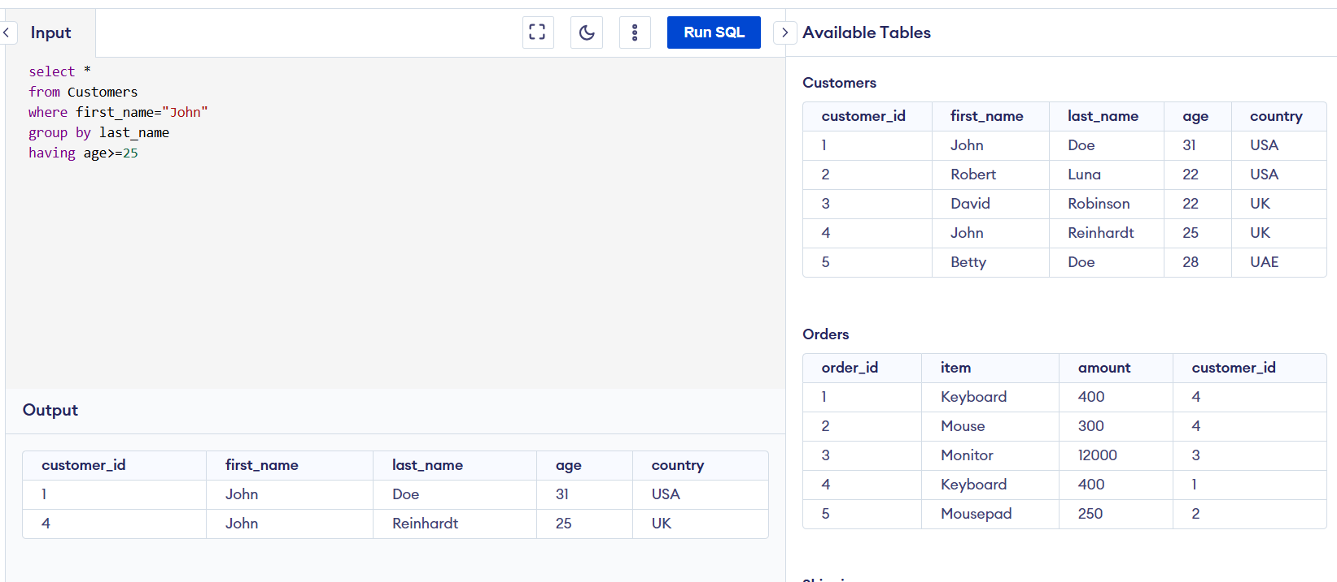

1. Not in

Syntax:

Select *

From table_name

Where column_name not in (value1,value2)

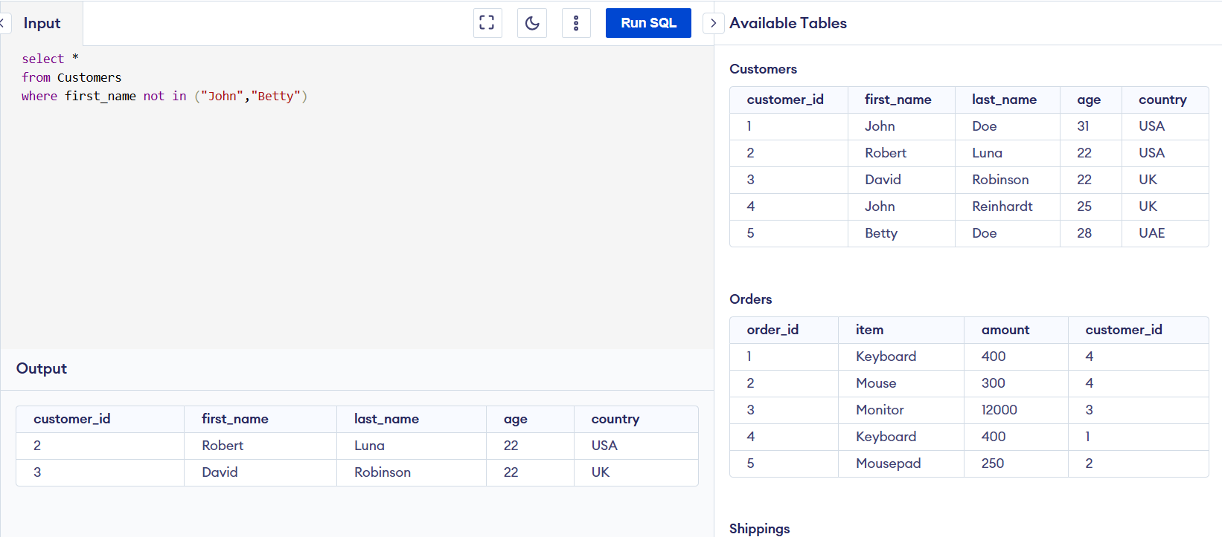

1. Is null

Syntax:

Select *

From table_name

Where column_name is null

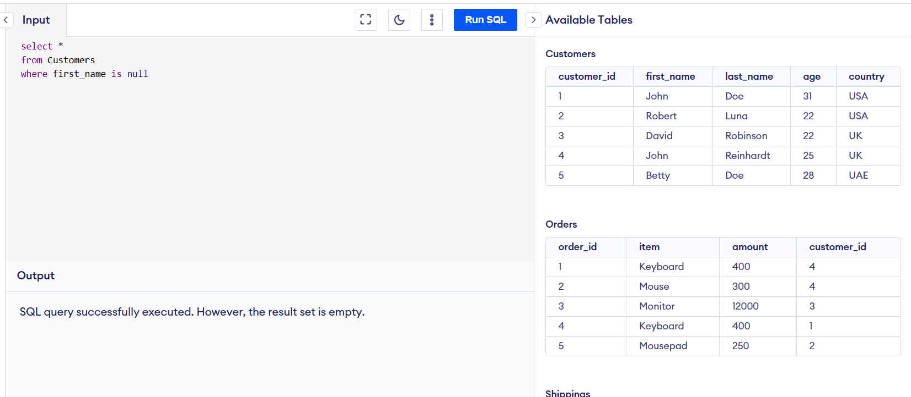

1. Is not null

Syntax:

Select *

From table_name

Where column_name is not null

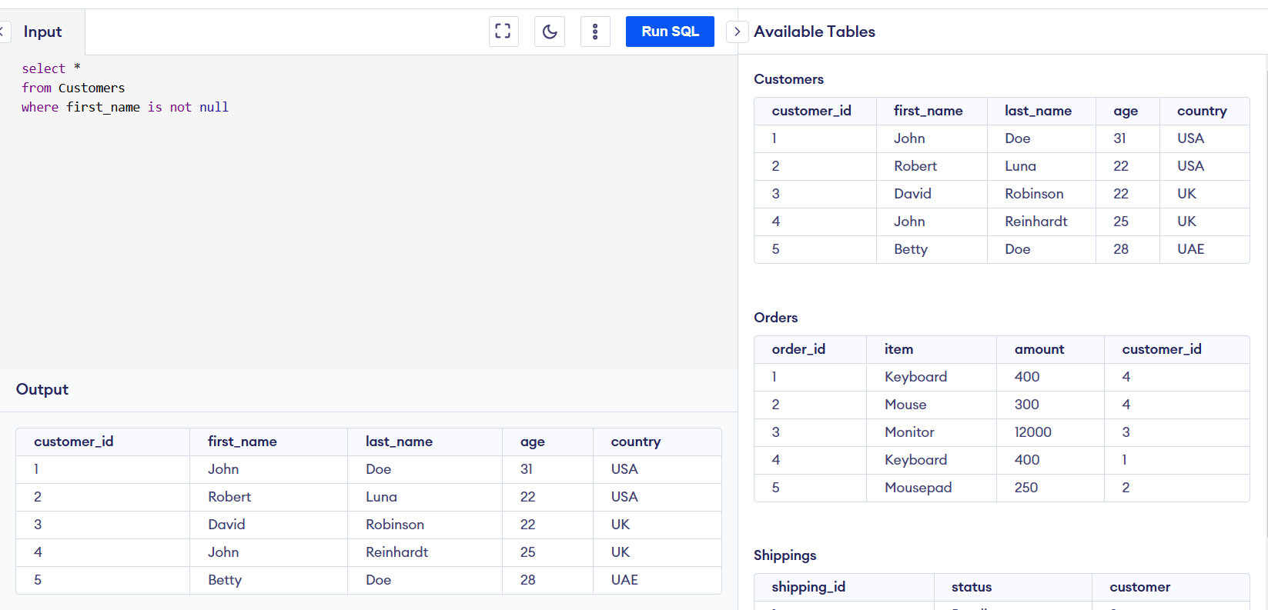

1. Like

Syntax:

Select *

From table_name

Wher column_name like “M%”

